**Smart EcoSort: Waste Segregation System for Efficient Waste Management**

**An Engineering Project in Community Service**

**Final Report**

***Submitted by***

**Lalit Sahu 21MEI10052**

***in partial fulfillment of the requirements for the degree of***

***Bachelor & Integrated Master of Technology***



**VIT Bhopal University**

**Bhopal**

**Madhya Pradesh**

**March, 2024**

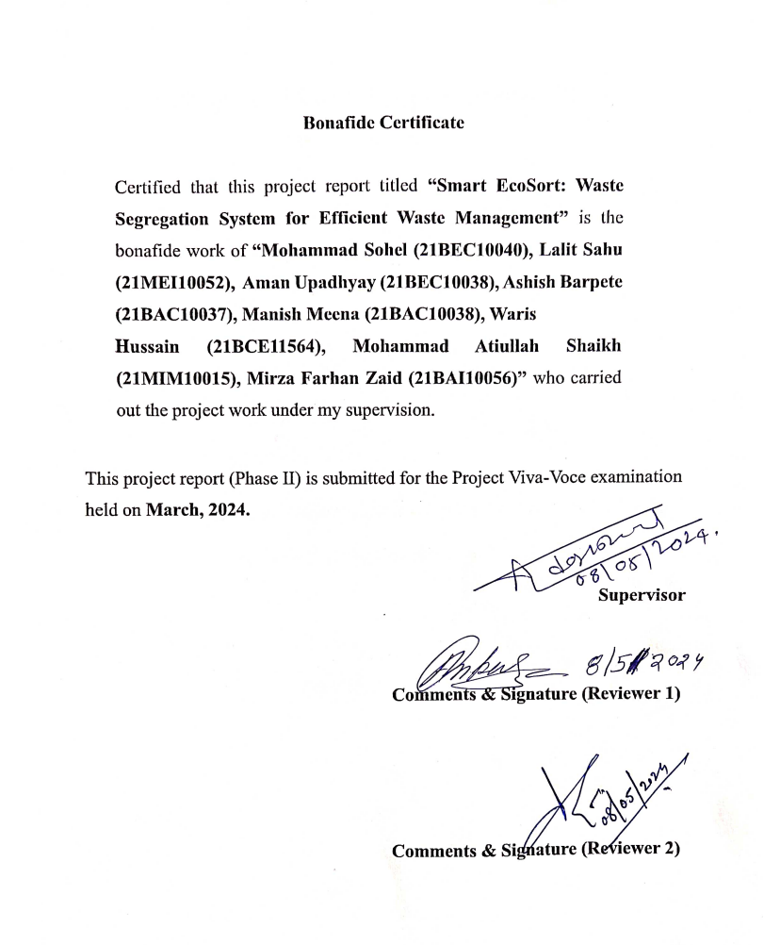



**Declaration of Originality**

We, hereby declare that this report entitled **“Smart EcoSort: Waste Segregation System for Efficient Waste Management”** represents our original work carried out for the EPICS project as a student of VIT Bhopal University and, to the best of our knowledge, it contains no material previously published or written by another person, nor any material presented for the award of any other degree or diploma of VIT Bhopal University or any other institution. Works of other authors cited in this report have been duly acknowledged under the section ''References''.

Lalit Sahu (21MEI10052)

|  |  |  |
| --- | --- | --- |
|  |  |  |



**INDEX**

|  |  |  |
| --- | --- | --- |
| S. NO. | TOPIC | PAGE NO. |
| 1. | Introduction | 4 |
| 2. | Motivation | 4 |
| 3. | Objective | 5 |
| 4. | Research Gap | 5 |
| 5. | Problem Statement | 6 |
| 6. | Literature Review | 7 |
| 7. | Types of Waste | 8 |
| 8. | Topic of the work | 9 |
| 8.1 | System Design | 9 |
| 8.2 | Working Principle | 9 |
| 8.3 | Expected Result | 10 |
| 9. | Fow Chart | 11 |
| 10. | Challenges | 11 |
| 11. | Conclusion | 12 |
| 12. | Contribution | 12 |
| 13. | References | 15 |

# INTRODUCTION

Urbanization has resulted in exponential rises in municipal solid waste worldwide, presenting significant issues in waste management for cities transforming into "smart cities" in terms of economy, health, and ecology. The present reliance on manual sorting and inadequate collecting techniques has led to serious pollution, unregulated disposal, and worker exposure to dangerous materials. But by automating trash sorting, technology like our sensor-enabled dual-compartment dustbin provides solutions.

Our innovative, sensor-enabled, dual-compartment dustbin takes the forefront, ready to completely transform the way garbage is managed today. Our state-of-the-art prototype aims to overcome the constraints of current methods by smoothly automating the complex process of trash separation.

Our dustbin's characteristics include its capacity to distinguish between garbage that is biodegradable and non-biodegradable, giving administrators access to real-time data for intelligent planning while relieving homes of the labor-intensive task of manual sorting. Extensive testing will demonstrate its effectiveness in simplifying trash management procedures and improving general convenience for towns facing swift urbanization.

It is becoming more and more clear that our dustbin prototype has the ability to revolutionize waste management as we move closer to the next stage of our pilot trials. A successful implementation might lead to a paradigm change in various communities' waste management techniques towards ones that are safe, sustainable, and intelligent. Our technology's anticipated commercialization has the potential to spark a technological revolution and redefine how societies manage and profit from their waste resources. In addition to being a container, our trash can is a vital component of a future urban landscape that is greener, more productive, and ecologically conscious.

## 2. MOTIVATION

As you're aware, our university sends students for experiential learning experiences in Pune and Hyderabad. During our visit, we discovered an interesting setup: there were two distinct bins provided for waste disposal. The first bin was designated for biodegradable garbage, while the second was for non-biodegradable items. However, we observed that some individuals, particularly those with limited literacy, struggled to grasp the concept. Distinguishing between biodegradable and non-biodegradable waste posed a challenge for them. Consequently, the government has deployed manpower to assist in educating people about waste segregation. Each garbage collection vehicle is now accompanied by personnel who guide citizens on the appropriate disposal methods.

Recognizing this prevalent issue, we pondered over possible solutions, contemplating the integration of cutting-edge technology to streamline the process.

## 3. OBJECTIVE

* **Efficient Segregation:** Create a compact, low-cost system that efficiently segregates household waste into categories (metallic, dry, and wet) for proper disposal1.
* **Health and Environment:** Reduce reliance on manual rag pickers and minimize health risks associated with handling waste. Proper segregation at the source can prevent infections and improve overall health1.
* **Economic Value:** Highlight the economic value of waste by ensuring effective recycling. Recycling helps conserve resources and cut down on waste1.
* **Environmental Impact:** Address environmental concerns related to open dumping and harmful waste disposal methods. The project aims to protect plant, animal, and human life.
* **User-Friendly Solution:** Design an easy-to-use system that streamlines waste management for urban households.

**4. RESEARCH GAP**

* **Infrastructure and Behavioral Challenges:** While the proposed waste segregator system shows promise, its implementation may encounter significant infrastructure requirements and necessitate behavioral changes. There's a gap in understanding how to effectively address resistance stemming from perceived inconvenience or cost implications, hindering widespread adoption.
* **Limitations in Experimental Evaluation:** Existing experimental evaluations of waste segregator systems, such as the AWS system, are promising but may lack comprehensive validation. There's a research gap in conducting broader evaluations encompassing diverse waste scenarios to provide more robust validation of the system's effectiveness.
* **Sensor Accuracy Concerns:** The testing results highlight limitations in sensor accuracy, particularly regarding certain waste types detected by capacitive proximity sensors. This raises concerns about the reliability of the system in real-world scenarios. Further research is needed to refine sensor technologies or explore alternative sensor options to improve accuracy.
* **Cost Prohibitive Setup:** Initial setup and installation costs, including components like ultrasound sensors and microcontrollers, may deter potential users or municipalities from adopting the proposed waste segregator system. There's a gap in research addressing how to reduce setup costs or develop more cost-effective solutions to promote widespread adoption.

**5. PROBLEM STATEMENT**

**Background:** Waste management is a critical challenge faced by urban areas and metro cities. The increasing population, rapid urbanization, and changing consumption patterns contribute to the mounting waste crisis. Proper waste handling is essential to prevent environmental degradation, health risks, and resource depletion.

* **Reduce, Reuse, and Recycle:**
  + Despite awareness campaigns, effective implementation of the “3 Rs” (Reduce, Reuse, and Recycle) remains a challenge.
  + Encouraging citizens to reduce waste generation and adopt sustainable practices is crucial.
* **Weak Regulations:**
  + Existing waste management regulations often lack enforcement and monitoring.
  + Inadequate penalties for improper waste disposal contribute to littering and haphazard waste handling.
* **Projected India Waste:** 0.7 kg/person/day by 2025:
  + According to Invest India, India’s waste generation is projected to reach 0.7 kg per person per day by 2025.
  + This exponential growth demands innovative solutions to manage waste effectively.
* **Automate Waste Separation:**
  + Manual waste segregation is labor-intensive, time-consuming, and error-prone.
  + Automating the segregation process using technology can improve efficiency and accuracy.

# 6. EXISTING WORK / LITERATURE REVIEW

Efficient waste management is becoming an increasingly important issue with rapid urbanization and population growth. Improper waste disposal leads to environmental contamination, health hazards, and lost economic opportunities for recycling. Thus, there is a need for intelligent waste management solutions that allow for effective collection, sorting, and monitoring. Recent research has focused on developing automated systems for waste segregation along with smart monitoring technologies.

* **Automated Waste Segregation:** Multiple studies have proposed automated waste segregators that can sort trash into different categories using various sensors [1]. developed a system to differentiate between dry, wet, and plastic waste using infrared, raindrop, and moisture sensors. [2] segregated metal, plastic, paper and wet waste streams using inductive proximity, light dependent resistor, and liquid sensors. Such systems allow waste separation at source for more efficient downstream processing.
* **Smart Dustbins:** Along with segregators, smart dustbins have been designed with features like automatic opening when someone approaches [1]. They can have multiple compartments for dry, wet, and plastic wastes and monitor daily disposal rates through built-in sensors. This improves ease-of-use and provides waste analytics.
* **Waste Monitoring Systems:** IoT-based monitoring using sensors for real-time fill-levels paired with notification alerts has also emerged as a solution for smart waste management [2]. This allows timely collection while data storage on cloud platforms enables analysis. Monitoring enables data-driven collection strategies.
* **Recycling and Waste Reduction Concepts:** Several studies highlight the importance of recycling and the reduce-reuse-recycle hierarchy for sustainable waste management [4]. Organic waste holds promise as nutrient sources or for energy conversion. Increasing recycling rates can provide significant economic benefits in addition to reducing disposal volumes.
* **Segregation for Efficiency:** Finally, the literature emphasizes source-segregation as vital for efficient downstream handling on top of enabling recycling income. Separating waste decreases quantities for collection and provides purer segregated streams, easing processing requirements. However, public participation remains a barrier.
* **Conclusions and Future Research:** In summary, existing automated segregators, smart monitoring dustbins, sensor-based fill-level monitoring, and recycling initiatives represent progress toward intelligent waste management systems. However, significant gaps remain like increasing public involvement in separation and ongoing evaluation of emerging technologies at commercial scale. Integration of these disconnected systems alongside assessments of operational feasibility and life cycle costs offers one direction for further work. Additionally, expanding recyclables collections and reducing contamination could be enabled by better public outreach around separation paired with deployment of sorting technologies closer to the source.

**7. TYPE OF WASTE**

* **Organic Waste:** Imagine a bustling kitchen: vegetable peels, fruit cores, and leftover food scraps. These are the organic heroes. They decompose naturally, returning to the earth. Yard waste—those fallen leaves and grass clippings—joins the party. Composting bins welcome them with open arms. Biodegradability is their superpower.
* **Recyclable Waste:** Picture a recycling center: plastic bottles, glass jars, and aluminum cans. These recyclable warriors don their green capes. They’re destined for a second life. Recycling plants transform them into new products—a plastic bottle reborn as a fleece jacket, a glass jar reincarnated as a shiny vase. Their journey is circular, like a cosmic dance.
* **Hazardous Waste:** Enter the danger zone: hazardous materials. These are the rebels with warning labels. Paints, batteries, and electronic gadgets—they don’t play by the rules. Special handling required! They’re like the wild cards in a deck of waste. Handle with care, or they might unleash chaos upon the environment.
* **Biodegradable vs. non-biodegradable:** The cosmic balance: biodegradable materials break down naturally, returning nutrients to the soil. Non-biodegradables, stubborn and unyielding, resist decay. They linger, cluttering landfills and oceans. Our mission? To tip the scales toward sustainability.

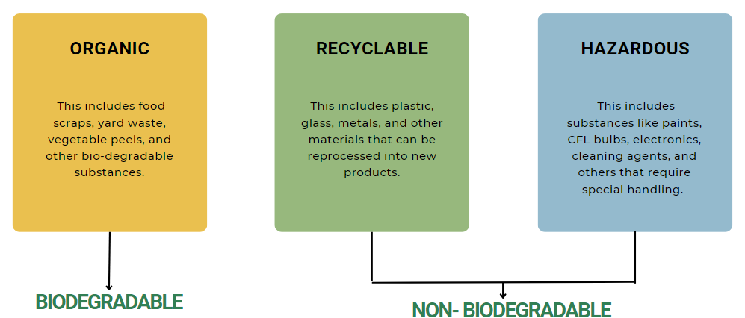

Fig. 1

# 8. TOPIC OF THE WORK

**8.1) System Design / Architecture:**

1. The waste segregator is designed to streamline waste disposal and recycling.
2. There are two containers inside: one for dry waste, one for non-biodegradable waste, and one for biodegradable waste.
3. Key components:
   * **Camera:** Captures images of the garbage.
   * **Machine Learning Model:** Analyzes the images to classify waste as biodegradable or non-biodegradable.
   * **Display:** Shows the segregation result.
4. The system ensures efficient sorting, reducing reliance on manual methods.

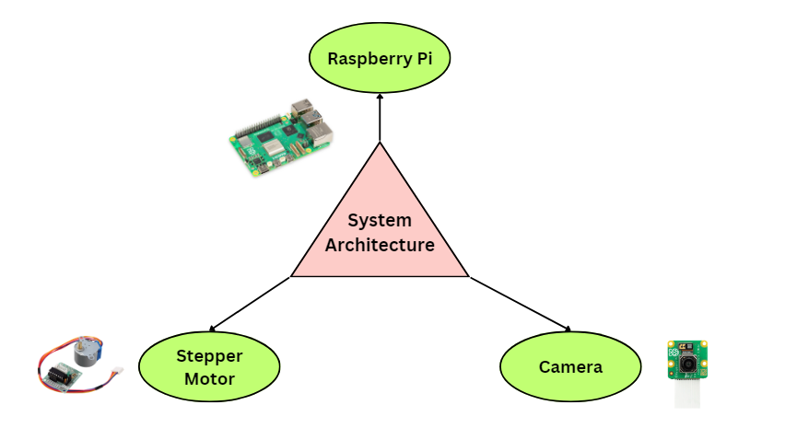

Fig. 2

**8.2) Working Principle:**

1. When garbage is placed in the system, the camera captures an image.
2. The machine learning model analyzes the image to determine if it’s biodegradable or non-biodegradable.
3. Based on the classification:
   * + Biodegradable waste goes to the its relevant dustbin.
     + None-Biodegradable waste also goes to its relevant dustbin.
4. The stepper motor guides the garbage to the appropriate bin.
5. The display shows the result of segregation.

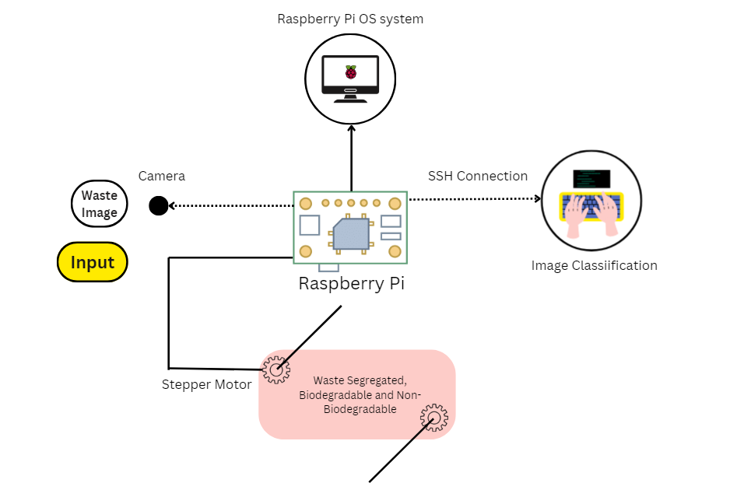

**8.3) Expected Results:**

* Efficient waste management:
  + Reduced contamination.
  + Increased recycling potential.
* Improved health and environmental impact:
  + Less reliance on rag pickers.
  + Proper waste disposal.
* Economic value realization:
  + Recycling opportunities.
  + Waste-to-energy possibilities (e.g., syngas generation).

**9. FLOWCHART**

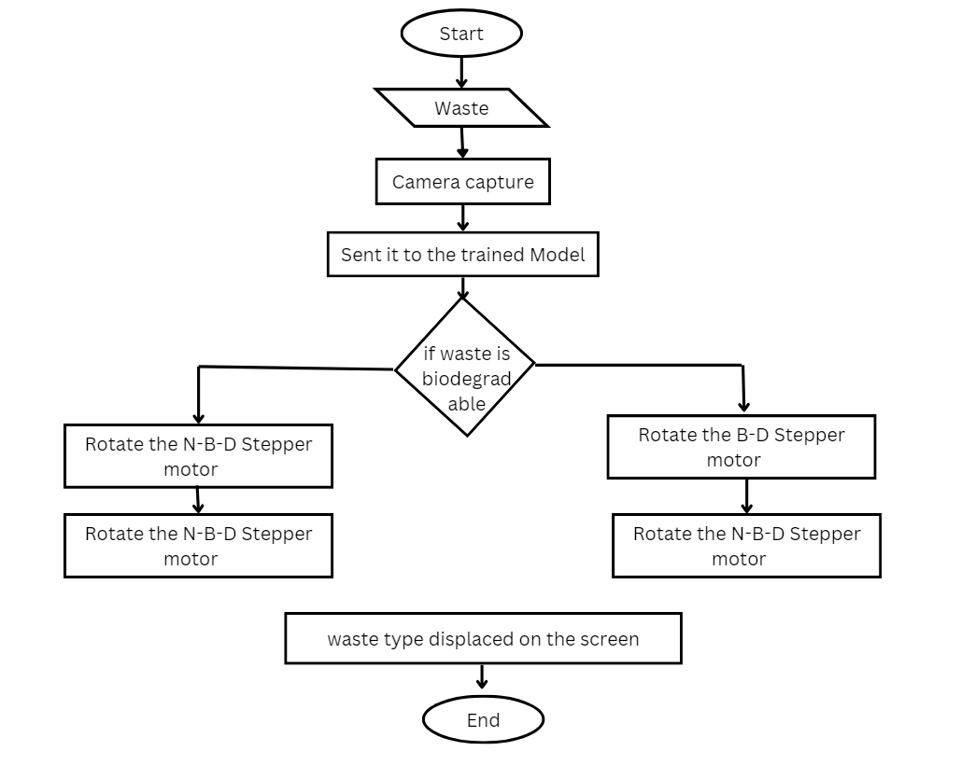

**10. CHALLENGES**

* **Image Quality and Lighting:** The accuracy of the machine learning model heavily relies on the quality of the captured images. Poor lighting conditions, blurry images, or cluttered backgrounds can affect the model’s performance.
* **Training Data:** To create an effective machine learning model, you’ll need a diverse dataset with labeled images of both biodegradable and non-biodegradable items. Gathering and curating this dataset can be time-consuming and challenging.
* **Model Selection and Tuning:** Choosing the right machine learning algorithm (such as convolutional neural networks) and fine-tuning its parameters is crucial. Finding the optimal balance between accuracy and speed is essential for real-time garbage sorting.
* **Real-Time Processing:** Processing images in real-time requires efficient hardware and software. Ensuring low latency and quick decision-making is essential for a responsive system.
* **Motor Precision and Reliability:** The stepper motor’s accuracy in directing garbage to the correct bin is critical. Mechanical wear, calibration, and motor reliability are challenges to address.
* **Environmental Factors:** Dust, humidity, and extreme temperatures can impact the camera’s performance and the overall system. Designing a robust enclosure to protect the components is essential.

# 11. CONCLUSION

As the curtain falls on our waste segregator project, we witness a harmonious blend of innovation and responsibility. Here’s the grand finale:

* **Environmental Symphony:** Our system orchestrates a symphony of sustainability. By sorting garbage at the source, it reduces contamination and ensures each item finds its rightful place.
* **Health Crescendo:** No more precarious scavenging by rag pickers. Our project hits the high notes of health and safety. Proper disposal means fewer infections and healthier communities.
* **Economic Overture:** Recycling takes center stage. The metallic treasures—aluminum cans, old keys—embrace their encore. Waste becomes a resource, a hidden gem waiting to shine.
* **User-Friendly Refrain:** Urban households applaud. The system’s simplicity invites participation. Garbage in, wisdom out. It’s a melody anyone can hum.

In this virtuoso performance, we’ve composed a greener future.

**12. Contribution**

* **Lalit Sahu - Documentation: Report, PPT, Creating Figures.**
  + **Role:** Responsible for creating comprehensive documentation and visual aids for the project.
  + **Contributions:**
    - Prepares detailed reports and presentations outlining the project's objectives, methodology, and outcomes.
    - Creates visually appealing figures and diagrams to illustrate the system architecture and workflow.
    - Ensures clarity and coherence in documentation to facilitate understanding by stakeholders and end-users.

# Reference:

1. W. Pereira, S. Parulekar, S. Phaltankar and V. Kamble, "Smart Bin (Waste Segregation and Optimisation)," 2019 Amity International Conference on Artificial Intelligence (AICAI), Dubai, United Arab Emirates, 2019, pp. 274-279, doi: 10.1109/AICAI.2019.8701350.

2. Jacob M. Kihila, Kris Wernsted & Mengiseny Kaseva (2021) Waste segregation and potential for recycling -A case study in Dar es Salaam City, Tanzania, Sustainable Environment, 7:1, DOI: 10.1080/27658511.2021.1935532.

3. Gour, A. A., & Singh, S. K. (2022). Solid Waste Management in India: A State-of-the-Art Review. Environmental Engineering Research, 28(4), 220249–0. <https://doi.org/10.4491/eer.2022.249>.

4. Batais, R., Abdulla, R., & Bahrin, S. M. (2020). Waste separation smart dustbin. ResearchGate. <https://www.researchgate.net/publication/341878744_Waste_Separation_Smart_Dustbin>.

5. C. P. Singh, M. Manisha, P. -A. Hsiung and S. Malhotra, "Automatic Waste Segregator as an integral part of Smart Bin for waste management system in a Smart City," 2019 5th International Conference On Computing, Communication, Control And Automation (ICCUBEA), Pune, India, 2019, pp. 1-5, doi: 10.1109/ICCUBEA47591.2019.9129508.

6. N. H. Kamarudin, A. A. A. Rahim, N. E. Abdullah, I. S. A. Halim and S. L. M. Hassan, "Development of Automatic Waste Segregator with Monitoring System," 2019 4th International Conference on Information Technology, Information Systems and Electrical Engineering (ICITISEE), Yogyakarta, Indonesia, 2019, pp. 190-195, doi: 10.1109/ICITISEE48480.2019.9003813.

7. Waste Segregation Conveyor using Raspberry Pi. (n.d.). Pantech eLearning. https://www.pantechelearning.com/product/waste-segregation-using-conveyor/

8. Gunaseelan, J., Sundaram, S., & Mariyappan, B. (2023, September 18). A Design and Implementation Using an Innovative Deep-Learning Algorithm for Garbage Segregation. MDPI. <https://doi.org/10.3390/s23187963>

**Biodata with Picture:**

**Lalit Sahu (21MEI10052):**

|  |  |
| --- | --- |
| Hello, I’m Lalit Sahu, currently pursuing an Integrated M.Tech specializing in Cyber Security at VIT Bhopal University. With a keen expertise in Cyber Security and a fervent passion for Ethical Hacking, I've undergone numerous courses to enhance my skills. I've completed courses on platforms like LinkedIn Learning and participated in relevant lectures. With over 3 years of hands-on experience in Cyber Security, I specialize in Penetration Testing for websites and mobile applications.  **LinkedIn:** <https://www.linkedin.com/in/lalit-sahu/> | **Lalit Sahu** |

**Plagiarism Checking:**

1. Duplichecker Website: <https://www.duplichecker.com/>

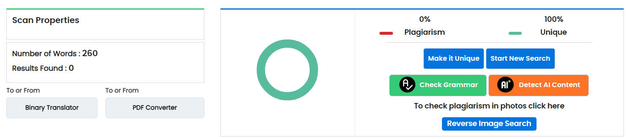

2. Plagiarismremover Website: <https://www.plagiarismremover.net/plagiarism-checker>



3. Smallseotools Website: <https://smallseotools.com/plagiarism-checker/>

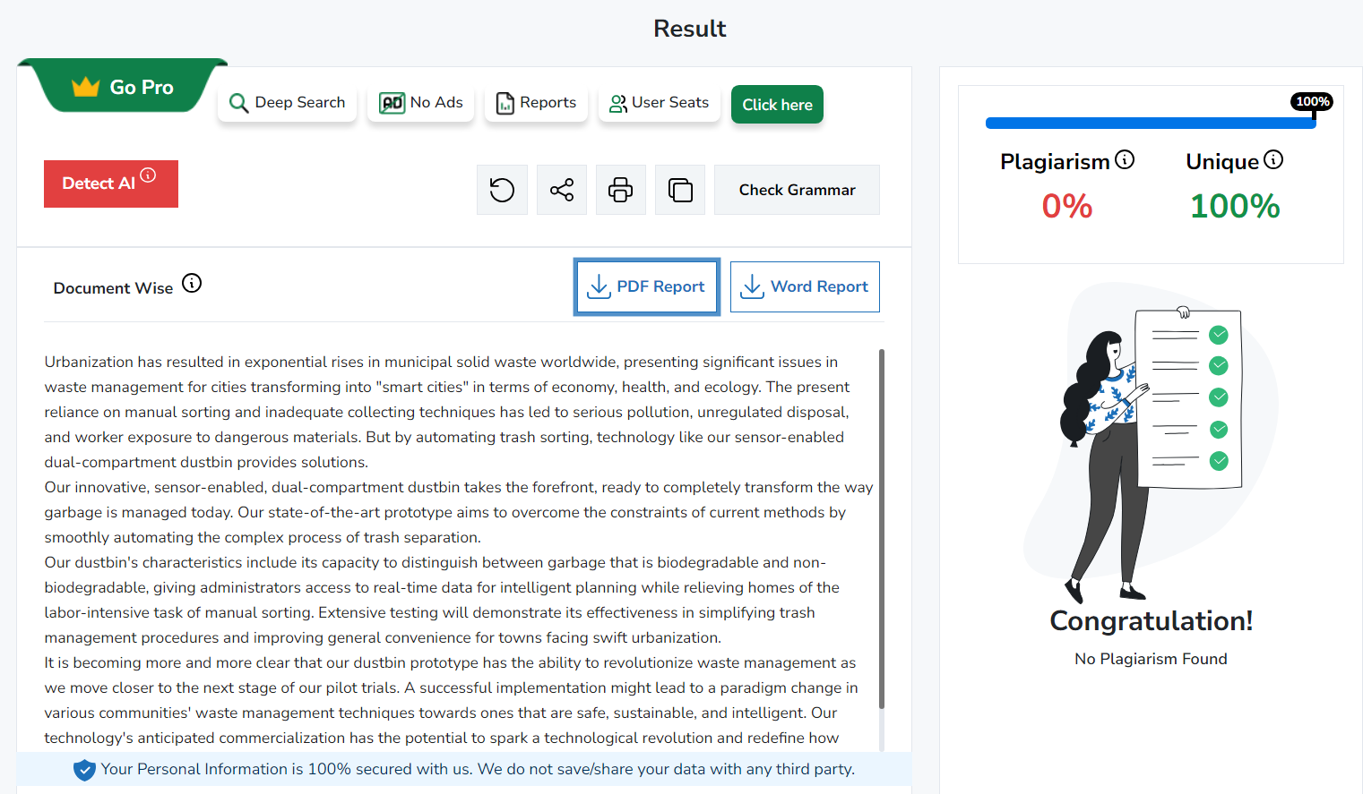

4. Grammarly Website: <https://www.grammarly.com/plagiarism-checker/>

